**INDICATOR ANALYSIS-WORLDWIDE**

**NAME: Sandeep Kumar Daki**

**Github file: https://github.com/Dakipaul/ADS1report.git**

**Abstract:** The following report shows youth unemployment for males in Spain, electricity access in Chile, the total population in Denmark and the GDP, The inter-country investigation for Chile and The inter-country investigation for Denmark. The visualization graphs helps us to understand the details.

**INTRODUCTION**

In this assignment, we are going to discuss about the climatic and economic indicators worldwide which helps us to understand the current position of a nation. We are going to look at the descriptive statistics and we would also identify the trend of these commonly used indicators. An inter-country investigation would also be done which would describe the association of different indicators.

**ANALYSIS**

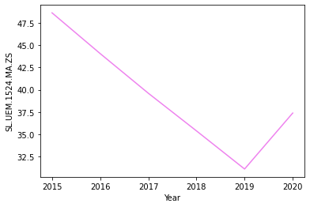 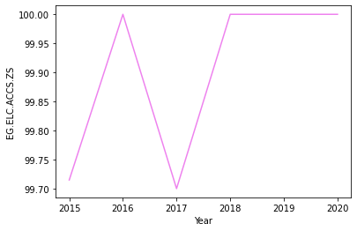

The visualization of youth unemployment for males in Spain in a line chart format demonstrates that this value decreases from 2015 to 2019 and it again increases in the year 2020.

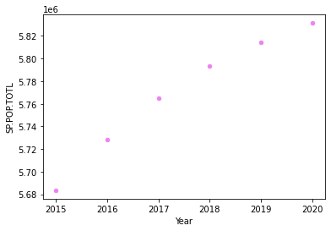

The visualization of the total population in Denmark in a scatter chart format demonstrates that this value has increased from the year 2015 to 2020The visualization of electricity access in Chile in a line chart format demonstrates that this value has been at its lowest levels in 2015 and 2017 and it has reached the peak value in the year 2016, 2018, 2019 and 2020

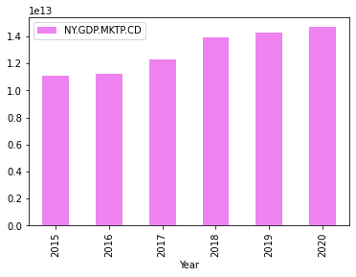

The visualization of the GDP in USD in China in a bar chart format demonstrates that this value has increased from the year 2015 to 2020

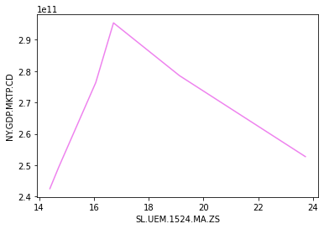 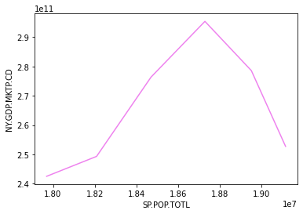

The inter-country investigation for Chile demonstrates that the association between GDP and male youth unemployment is direct in nature till the time, the value of male youth unemployment crosses 16% and after that the association between them is indirect

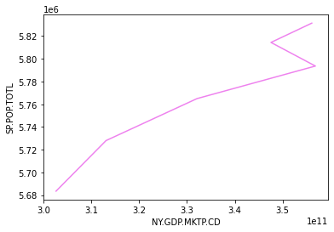

The inter-country investigation for Denmark demonstrates that the association between the GDP and the total population is direct in nature

**CONCLUSION**

* The youth unemployment for males in Spain has seen a decrease from 2015 to 2019 and it has again increased in the year 2020.
* The electricity access in Chile has been low in 2015 and 2017 but in 2016, 2018, 2019, and 2020, the value was 100%
* The total population in Denmark and the GDP in USD in China have increased from the year 2015 to 2020.

The inter-country investigation for Chile demonstrates that the association between GDP and the total population is direct in nature till the time, the value of the total population crosses 1.88 and after that the association between them is indirect

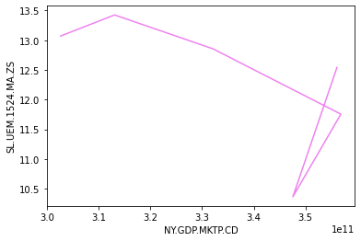

The inter-country investigation for Denmark demonstrates that the association between GDP and male youth unemployment is direct in nature till the time, the value of male youth unemployment crosses 3.1 and after that the association between them is indirect

* The inter-country investigation for Chile indicates a direct association between GDP and male youth unemployment, but after a certain value of male youth unemployment, the association becomes indirect.
* The inter-country investigation for Denmark indicates a direct association between GDP and the total population.
* The inter-country investigation for Denmark indicates a direct association between GDP and male youth unemployment, but after a certain value of male youth unemployment, the association becomes indirect.